**Hand Gesture Recognition Using Deep Learning**

Report

Submitted in the partial fulfillment of the requirements for the award of the degree of

**Artificial Intelligence for Data Science**

By

**2010030505-ISUNURI LAXMAN SAI**

**2010030444-SAI KIRAN**

**2010030492-VAMSHI M**

**2010030147-SAI CHARAN**

under the supervision of

# Dr.K SREENIVASA RAO

Assistant Professor



Department of Computer Science and Engineering

K L University Hyderabad,

Aziz Nagar, Moinabad Road, Hyderabad – 500 075, Telangana, India.

**Declaration**

The Report entitled “**Hand gesture recognition using deep learning**” is a record of the bonafide work of I.Laxman sai –(2010030505), D.Sai kiran-(2010030444), M.Vamshi – (2010030492),Sai charan – (2010030147) submitted in partial fulfillment for the award of B.Tech in the Department of Computer Science and Engineering to the K L University, Hyderabad. The results embodied in this report have not been copied from any other Departments/universities/institutes.

Signature of the Students :

Laxman sai

Sai kiran

Vamshi

Sai charan

**Certificate**

This is to certify that the Report entitled “**Hand Gesture Recognition Using Deep Learning**” is being submitted by I.Laxman sai –(2010030505), D.Sai kiran-(2010030444), M.Vamshi – (2010030492),Sai charan – (2010030147)) submitted in partial fulfillment for the award of B.Tech in Computer Science Engineering (CSE) to the K L University, Hyderabad is a record of bonafide work carried out under our guidance and supervision.

The results embodied in this report have not been copied from any other departments/universities/institutes.

## Signature of the Supervisor

Dr.K Sreenivasa Rao

Assistant Professor

## Signature of the HOD Signature of the External Examiner

**ACKNOWLEDGEMENT**

First and foremost, we thank the lord almighty for all his grace & mercy showered upon us, for completing this project successfully.

We take a grateful opportunity to thank our beloved Founder and Chairman who has given constant encouragement during our course and motivated us to do this project. We are grateful to our Principal **Dr. L. Koteswara Rao** who has been constantly bearing the torch for all the curricular activities undertaken by us.

We pay our grateful acknowledgment & sincere thanks to our Head of the Department

**Dr. Chiranjeevi Manike** for her exemplary guidance, monitoring, and constant encouragement throughout the course of the project. We thank **Dr.K Sreenivasa rao** of our department who has supported us throughout this project holding the position of supervisor.

We wholeheartedly thank all the teaching and non-teaching staff of our department without whom we won’t have made this project a reality. We would like to extend our sincere thanks, especially to our parents, our family members, and our friends who have supported us to make this project a grand success.

**TABLE OF CONTENTS**

|  |  |  |
| --- | --- | --- |
| **S.NO** | **TITLE** | **PAGE NO** |
| 0 | Project Abstract | 6 |
| 1 | Introduction | 7 |
| 2 | Problem Statement | 8 |
| 3 | Motivation | 8 |
| 4. | Objective | 9 |
| 5 | Literature Review | 9-11 |
| 6 | Related Work | 12 |
| 7 | Dataset | 13-14 |
| 8 | Methodology | 15-16 |
| 9 | Implementation | 17-22 |
| 10 | Results Dicussion | 23 |
| 11 | Conclusion & Futurework | 24 |
| 12 | References | 25 |

**ABSTRACT**

Computer vision is the study it deals with the computers and systems which understand or takes data through images, videos, or any other visual inputs. It acts as a human visual system and can carry on tasks we specify. Hand gesture recognition is very significant for human-computer interaction. Hand gesture recognition systems received great attention in the recent few years because of their applications and the ability to interact with machines efficiently through human-computer interaction. These are a form of nonverbal communication that can be used in several fields such as communication between deaf-mute people, robot control, human-computer interaction (HCI), home automation, and medical applications.  Due to the effect of lighting and complex background, most visual hand gesture recognition systems work only in a restricted environment. An adaptive skin color model based on face detection is utilized to detect skin color regions like hands.

**1. INTRODUCTION:**

Hand gestures are a form of nonverbal communication that can be used in several fields such as communication between deaf-mute people, robot control, human-computer interaction (HCI), home automation, and medical application. This is an area with many different possible applications, giving users a simpler and more natural way to communicate with robots/systems interfaces, without the need for extra devices. The vision-based technology of hand gesture recognition is an important part of human-computer interaction (HCI). In the last decades, keyboard and mouse play a significant role in human-computer interaction. However, owing to the rapid development of hardware and software, new types of HCI methods have been required. In particular, technologies such as speech recognition and gesture recognition receive great attention in the field of HCI.

The gesture is a symbol of physical behavior or emotional expression. It includes body gestures and hand gestures. It falls into two categories: static gesture and dynamic gesture. For the former, the posture of the body or the gesture of the hand denotes a sign. For the latter, the movement of the body or the hand conveys some messages. Gestures can be used as a tool of communication between computers and humans. Some methods used additional hardware devices such as data glove devices and color markers to easily extract the comprehensive description of gesture features. Other methods are based on the appearance of the hand using the skin color to segment the hand and extract necessary features, these methods are considered easy, natural, and less cost compared with methods mentioned before.

In our project gestures are continuously monitored by the webcam. Each gesture corresponds to a specific command. The workflow of hand gesture recognition is described as follows. First, the hand region is detected from the original images from the input devices. Then, some kinds of features are extracted to describe hand gestures. Last, the recognition of hand gestures is accomplished by measuring the similarity of the feature data.

1. **PROBLEM STATEMENT:**

Our idea is to Create a system that can identify specific human hand gestures and use them to address some of the basic handicapped people to interact with the systems also people to intrect with machines using convolutional neural networks.

**3. MOTIVATION:**

**Biometric technologies make use of various physical and behavioral characteristics of human such as fingerprints, expression, face, hand gestures and movement. These features are then processed using sophisticated machines for detection and recognition and hence used for security purposes. Unlike common security measures such as passwords, security cards that can easily be lost, copied or stolen; these biometric features are unique to individuals and there is little possibility that these pictures can be replaced or altered.**

**Among the biometric sector hand gesture recognition are gaining more and more attention because of their demand regarding security for law enforcement agency as well as in private sectors such as surveillance systems.**

**In video conferencing system, there is a need to automatically control the camera in such a way that the current speaker always has the focus. One simple approach to this is to guide the camera based on sound or simple cues such as motion and skin color.**

**Hand gestures are important to intelligent human and computer interaction to build fully automated systems that analyze information contained in images, fast and efficient hand gesture recognition algorithms are required.**

**4. OBJECTIVE:**

• The user can interact with the virtual environment using hand gestures.

• No Special Hardware is Necessary, except for the Camera.

**5. LITERATURE SURVEY**

|  |  |  |  |  |  |  |  |  |
| --- | --- | --- | --- | --- | --- | --- | --- | --- |
| S.NO | Authors | Title | | Publishing | | Techniques & dataset | Pros | |
| 1. | [Kevin Simon](https://mantra.ai/blogs/author/nivin-simon/) | How does AI recognize your hand gestures and movements | | [2019 MANTRA.AI](https://mantra.ai/blogs/ai-in-gesture-recognition/) | | [Static Gesture Recognition DataSet](https://medium.com/@blackbird98/sign-language-and-static-gesture-recognition-eaafd6ab00a5) | 1. We can look forward to  gestural recognition applications moving into education, real estate, fashion design, and even law enforcement.  2. The consumer electronics market is set to lead the forecasted demand and growth for this technology, leading to an increase in the number of vendors creating ground-breaking applications in this space. | |
| 2. | Yacine BENAFFANE | [Deep Learning] Hand gesture recognition | | [Jan 14, 2020](https://becominghuman.ai/deep-learning-hand-gesture-recognition-b265f4e6cf02?source=post_page-----b265f4e6cf02-----------------------------------) | | Dataset hand gesture  EgoGesture | 1. Gesture recognition is a hot topic in computer vision and pattern recognition.  2. It’s an interesting aspect of our society, the signs will be able to help, depending on the case, to establish and improve existing communication. | |
| 3 | Ahmet Gunduz | Real-time Hand Gesture Detection and Classification Using Convolutional Neural Networks | | 29 Jan 2019 | | EgoGesture and NVIDIA Dynamic Hand Gesture Datasets | 1. An acceptable classification accuracy  2. Fast reaction time  3. Resource efficiency  4. Single-time activation per each performed gesture. | |
| 4. | Viraj Shinde, Tushar Bacchav, Jitendra Pawar, Mangesh Sanap | Hand Gesture Recognition System Using Camera | | 1, January - 2014 | | Object detection, Object tracking, Object recognition | 1.Reduce external Interface:  The Advantage of System is to Reduce External Interface like Mouse And Keyboard.  2.High Portability :  The proposed System reduce the working of external interface like keyboard and mouse so it makes it high portable. | |
| 5. | Alexandre Campeau-Lecours | Deep Learning for Electromyographic Hand Gesture Signal Classification Using Transfer Learning | 10 Jan 2018 | | MyoArmbandDataset | | Artificial intelligence can be leveraged to increase the autonomy of people living with disabilities. |
| 6. | Abdullah Mujahid , Mazhar Javed Awan , Awais Yasin | Real-Time Hand Gesture Recognition Based on Deep Learning YOLOv3 Model | 2 May 2021 | | DarkNet-53 | | In this paper, we have proposed a lightweight model based on the YOLOv3 and DarkNet-53 deep learning models for hand gesture recognition.  For future work, we will be focusing on hybrid methods with smart mobile applications or robotics with different scenarios. | |
| 7. | Adithya V, Rajesh R | A Deep Convolutional Neural Network Approach for Static Hand  Gesture Recognition | 4 June 2020 | | Convo-  lutional neural network (CNN) | | The proposed CNN architecture eliminates the need of detection and segmentation of hands from the captured images, thus reducing the computational burden faced during hand posture recognition with classical approaches. | |
| 8. | Peng Liu, Xiangxiang Li | Hand Gesture Recognition Based on Single-Shot Multibox Detector Deep Learning | 30 Dec 2019 | | CNN | | We chose four character’s hand gestures under three different complex backgrounds as the investigated objects.  The research results show that the SSD algorithm can be used in the hand gesture recognition system for the human-computer interaction application. | |
| 9. | Xiaoguang Yu, Yafei Yuan | Hand Gesture Recognition Based on Faster-RCNN Deep Learning | October 31, 2018 | | regional convolutional neural network (Faster-RCNN) | | In summary, the faster region full convolution neural network (Faster-RCNN) depth learning algorithm is proposed to apply for gesture recognition in this work.  We chose five characters hand gesture under three different complex backgrounds as the investigated objects. | |
| 10. | Manju Khari, Aditya Kumar Garg1 | Gesture Recognition of RGB and RGB-D Static Images Using Convolutional Neural Networks | 16 September 2019 | | CNN | | CNN is currently a powerful artificial intelligence tool that can recognize patterns with high accuracy.  The proposed model is tested on ASL dataset and the recognition rate attained is 94.8% | |

**6. RELATED WORK**

Hand Gesture Recognition involves a variety of techniques from diverse areas. First let us do prior work related to Sign Language Recognition. The first step of Sign Language Recognition is to capture the symbols performed by the user. To do this we need to examine sensors that provide the best balance between frame rate, accuracy, and affordability. Then, we present a set of sensors that cover a raise of capture devices and their aspects. With sensors to capture the scene the next step is to track and recognize the user’s body and different parts of it, such as the face, arms, and hands. Methods for recognizing bodies and body parts have been widely studied and a diverse set of applications created. Neural Networks (NN) are often used as recognition models for image processing. In this project, we present a basic NN model and some variations applied to different areas. We focus on a specific type of network, Convolutional Neural Network (CNN), a popular NN in image processing because of its success in recognizing local features. This way of interacting avoids the use of physical control devices, allowing natural communication with the computer. The focus is on developing methods to provide an effective user experience when interacting with the computer.

**7. DATASET**

# In our project, we are using Hand Gesture Recognition Dataset with 20 Different Gestures with a total of 24000 images.  For training purposes, there are 900 images in each directory and for testing purposes, there are 300 images in each directory. This dataset is primarily used for hand gesture recognition tasks.

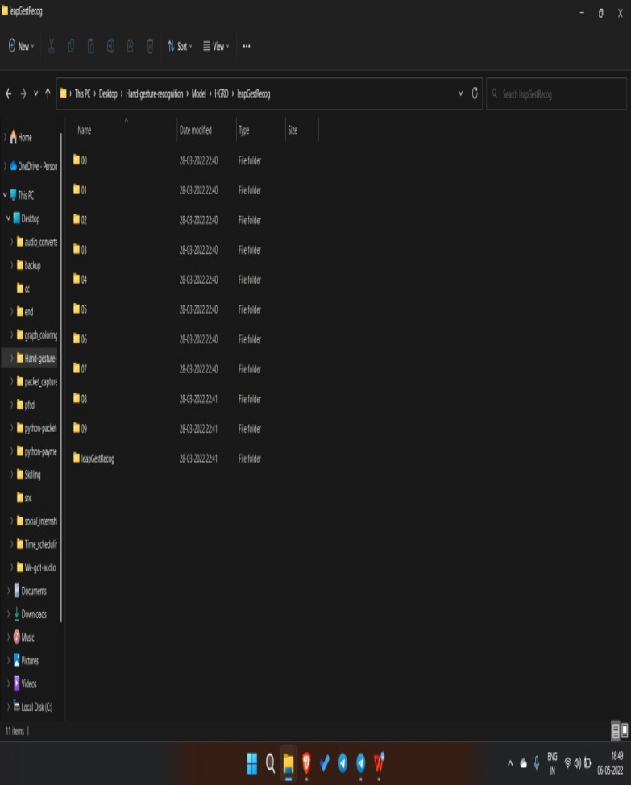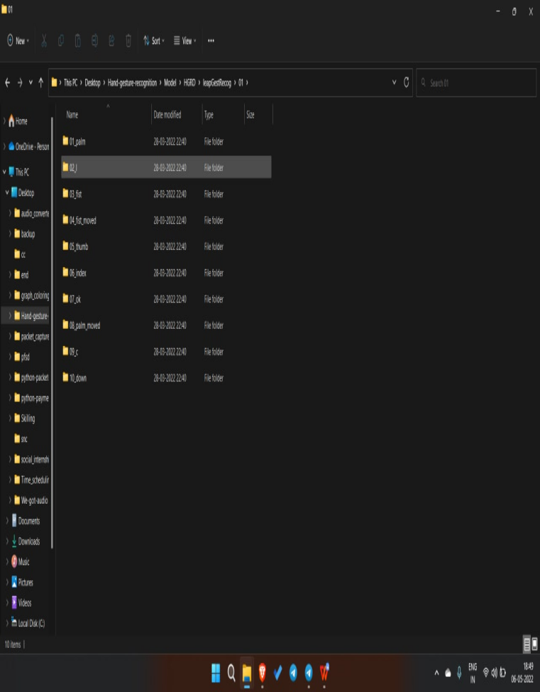

Fig 1 & 2: Categorized Similar images into different folders with proper labeling

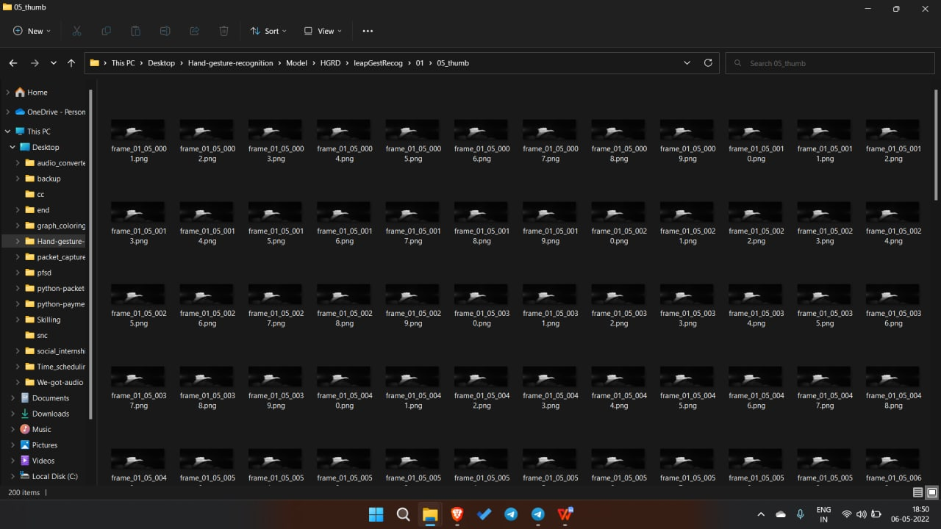

Fig 3: Gesture images of thumb sorted into one folder**7. METHODOLOGY**

**7.1 CNN model**

Convolutional neural networks (CNN) – the concept behind recent breakthroughs and developments in deep learning.CNNs have broken the mold and ascended the throne to become the state-of-the-art computer vision technique. Among the different types of neural networks (others include recurrent neural networks (RNN), long short term memory (LSTM), artificial neural networks (ANN), etc.), CNNs are easily the most popular. These convolutional neural network models are ubiquitous in the image data space. They work phenomenally well on computer vision tasks like image classification, object detection, image recognition, etc.

CNN is basically used for image analysis it detects patterns and makes sense of them, this pattern detection is useful for image analysis. The word convolutional refers to the filtering process that happens in the network. If there is a complex image the convolutional neural network simplifies it so it can be better processed and understood. The CNN or convolutional neural networks are the most commonly used algorithms for image classification problems. An image classifier takes a photograph or video as an input and classifies it into one of the possible categories that it was trained to identify. They have applications in various fields like driver less cars, defense, healthcare etc.

Using CNN is like watching an image through window which allows you to see specific features which you might not be able to see otherwise.

**7.2 Adam optimizer algorithm**

Adam is an optimization algorithm that can be used instead of the classical stochastic gradient descent procedure to update network weights iterative based in training data.Adam is different to classical stochastic gradient descent.

Stochastic gradient descent maintains a single learning rate for all weight updates and the learning rate does not change during training.

A learning rate is maintained for each network weight (parameter) and separately adapted as learning unfolds.

The advantages of two other extensions of stochastic gradient descent. Specifically:

* **Adaptive Gradient Algorithm** (AdaGrad) that maintains a per-parameter learning rate that improves performance on problems with sparse gradients (e.g. natural language and computer vision problems).
* **Root Mean Square Propagation** (RMSProp) also maintains per-parameter learning rates that are adapted based on the average of recent magnitudes of the gradients for the weight (e.g. how quickly it is changing). This means the algorithm does well on online and non-stationary problems (e.g. noisy).

Adam is a popular algorithm in the field of deep learning because it achieves good results fast.

**8. IMPLEMENTATION**

**8.1 DataSet lookup**

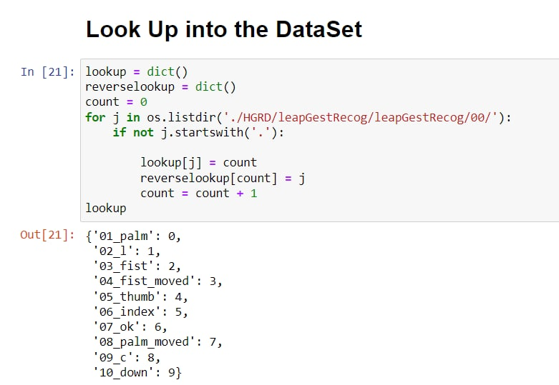

**8.2 Resizing the Data**

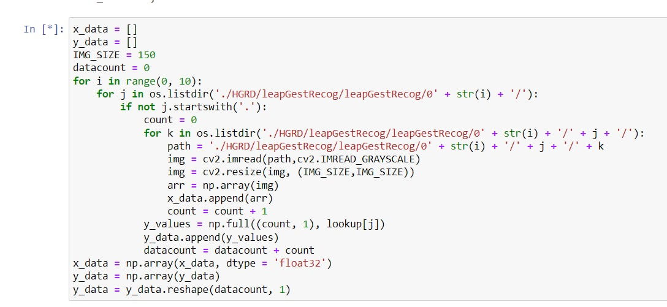

**8.3 Data cleaning and data processing**

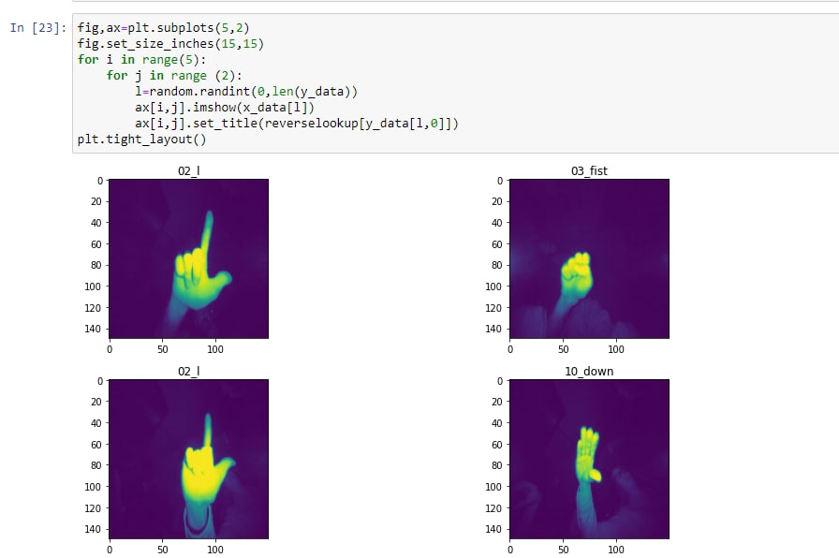

**8.4 Neural Network**

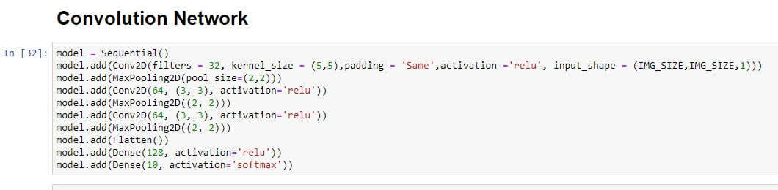

**8.5 Data Training**

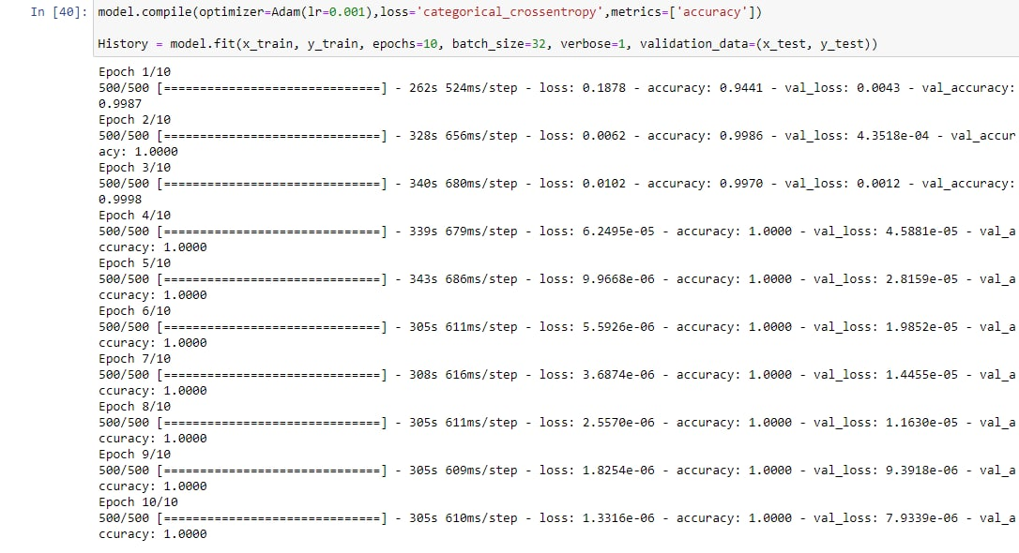

**8.6 Checking model accuracy**

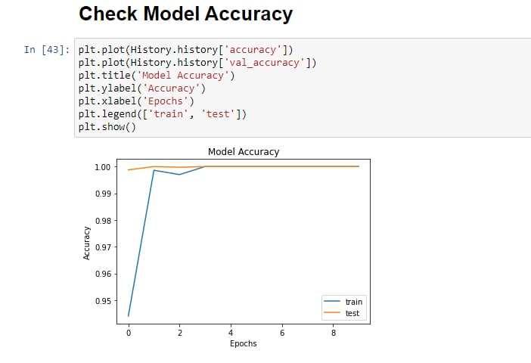

OUTPUT:-

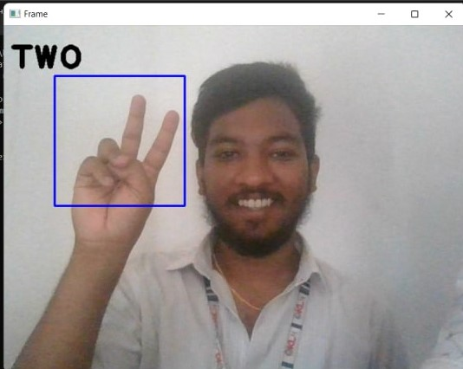

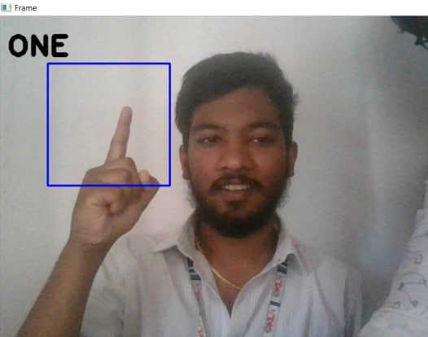

**9. RESULTS DISCUSSION:**

We have developed an output while predicting the gestures of persons .We have used the Hand gesture recognition detection dataset from Kaggle and did data cleaning from that dataset .Based on the results, a computer vision application could detect and recognize simple hand gestures for robot navigation using simple heuristic rules. While the use of moment invariants was not considered suitable because the same gestures could be used pointing in opposite directions, other learning algorithms like AdaBoost could be explored to make the program more robust and less affected by extraneous objects and noise.

**10. CONCLUSION AND FUTURE WORK**

In conclusion, Gesture recognition involves techniques from computer vision. The importance of gesture recognition lies in building efficient human-machine interaction.

CNN is a multi-layer neural network which is one of the deep learning techniques used efficiently in the field of gesture recognition. The user can interact with the machine using hand gestures more easily and quickly. No Special Hardware is Necessary, except for the Camera. Gesture recognition promises wide-ranging applications in the field. In the future, this project can be done by keeping track of all the various inputs such as hand gestures and giving cumulative results.

The system could also be made smart to be trained for only one or two gestures rather than all and then made ready for testing. This will require only a few changes in the current interface code, which were not performed due to the shortage of time.

One time training constraint for real time system can be removed if the algorithm is made efficient to work with all skin types and light conditions which seems impossible by now altogether. Framing with COG (Centre of gravity) to control orientation factor could make this system more perfect for real application.

**11. REFERENCES**

Mujahid, Abdullah, et al. "Real-time hand gesture recognition based on deep learning YOLOv3 model." Applied Sciences 11.9 (2021): 4164.

Mujahid, A., Awan, M. J., Yasin, A., Mohammed, M. A., Damaševičius, R., Maskeliūnas, R., & Abdulkareem, K. H. (2021). Real-time hand gesture recognition based on deep learning YOLOv3 model. Applied Sciences, 11(9), 4164.

Mujahid, Abdullah, Mazhar Javed Awan, Awais Yasin, Mazin Abed Mohammed, Robertas Damaševičius, Rytis Maskeliūnas, and Karrar Hameed Abdulkareem. "Real-time hand gesture recognition based on deep learning YOLOv3 model." Applied Sciences 11, no. 9 (2021): 4164.

Mujahid, A., Awan, M.J., Yasin, A., Mohammed, M.A., Damaševičius, R., Maskeliūnas, R. and Abdulkareem, K.H., 2021. Real-time hand gesture recognition based on deep learning YOLOv3 model. Applied Sciences, 11(9), p.4164.

Mujahid A, Awan MJ, Yasin A, Mohammed MA, Damaševičius R, Maskeliūnas R, Abdulkareem KH. Real-time hand gesture recognition based on deep learning YOLOv3 model. Applied Sciences. 2021 Jan;11(9):4164.